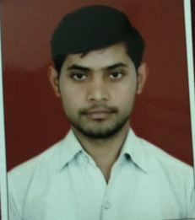
CV
DARSHIKA SINGH
Address : C-188, Gali no.- 4
West Vinod Nagar, Delhi- 110092.
Contact : +91 9654847540
E-Mail : darshika1singh@gmail.com
CAREER OBJECTIVES:

To work in an organization, provides me the opportunity to improve my skills and knowledge to growth along with the organization objective, and provides me job satisfaction and self-development.
PERSONAL INFORMATION:
- Father’s Name : Mr. Bhupender Singh
- Mother’s Name : Mrs.Sunita Devi
- Date Of Birth : July /25/ 1994
- Nationality : Indian
- Marital Status : Unmarried

- Languages knows : Hindi & English
QUALIFICATION

- MA Pursuing From IGNOU
- PG Diploma in Broadcast journalism (PGDBJ) fromITVSMM (New Delhi)
- Graduation from Janki Devi Memorial College, Delhi University in 2015
- H.S.C. from CBSE Board in 2012
- Intermediate from CBSE Board in 2010
WORK EXPERIENCE
2 Months Internship InIndiaNewsOutput Crime Desk (Ravi Sharma Team)
- 6 Months Job experience in YouTube Channel-NMF News
- 1 year Job experience in Digital Media. Web channel name- Himalayan News
- 6 Months Internship In India News Output General Desk
HOBBIES
- Reading books
- Experiment new things
- Photography
SKILLS

- Basic knowledge of Computer (Microsoft Office)
- Good Communication Skill
- Competitive
- Good Listener
- Hard Working
- Hindi & English Typing

Date: ______________ DARSHIKA SINGH.

